Employee Advance Salary Requests

This module allow employee to request for advance salary. Main Features  
  * Employee advance salary request  
  * Set salary limit on job position  
  * Department Manager Approval  
  * HR Officer/Manager Approval  
  * Director Approval  
  * Integrated with accounting for payment  
  * Integrated with HR Payroll / Employee Payslips

We have created Department Manager, Director groups under settings/users/groups to control whole process.

***Workflow: Draft->Confirmed->Approved by Department->Approved by HR->Approved by Director->Paid->Done***

**Menus Available:**

* *Employees/Advance Salary*
* *Employees/Advance Salary/Advance Salary Requests*
* *Employees/Advance Salary/Department Approvals*
* *Employees/Advance Salary/Director Approvals*
* *Employees/Advance Salary/HR Approvals*
* *Invoicing/Purchases/Advance Salary Requests*

Employee Advance Salary Requests

Under HR menu to request advance salary by employee (List view). Normal employee can see his/her on request.(Thanks to Security added in module)

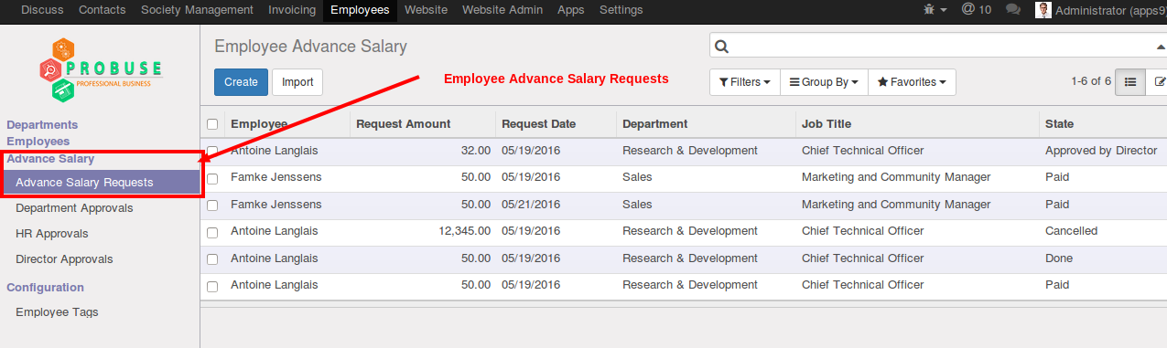

Employee Advance Salary Requests

This is salary advance form which employee has to fill if they want to request for advance salary.

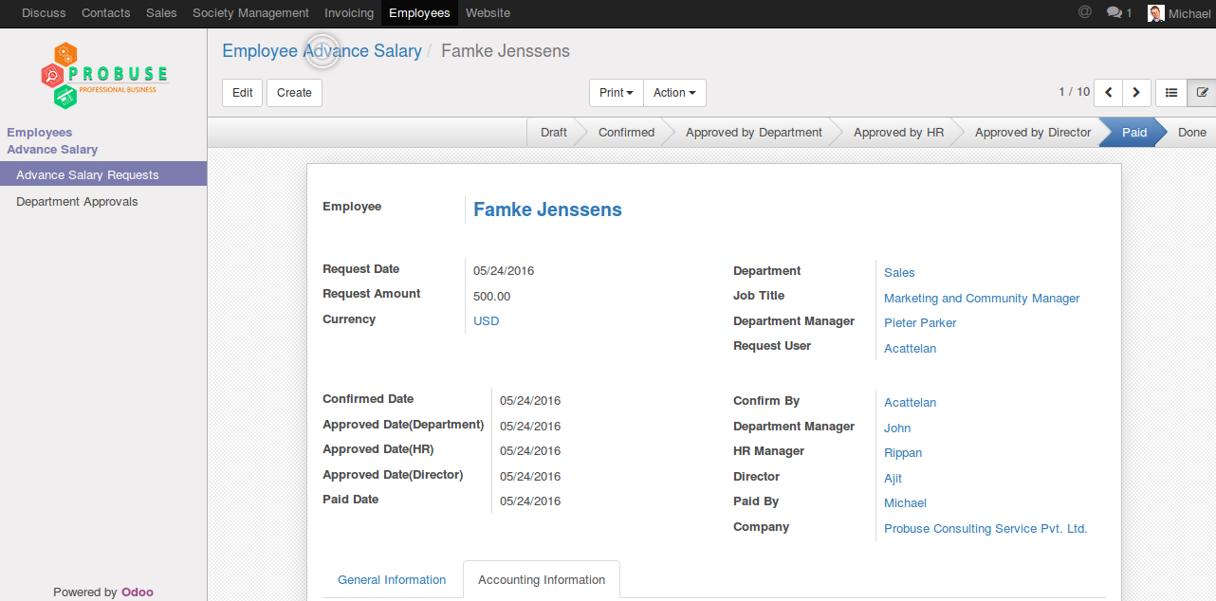

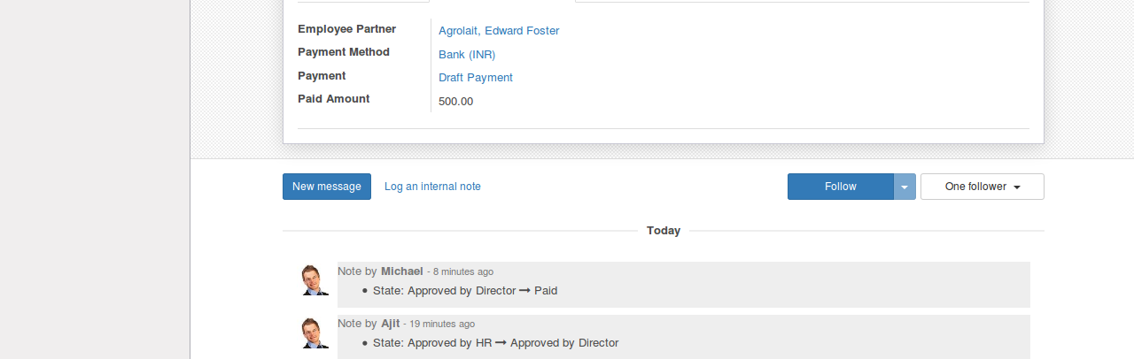

Set Salary Limit on Job Position

Allow HR manager to configure advance salary limit on job position.

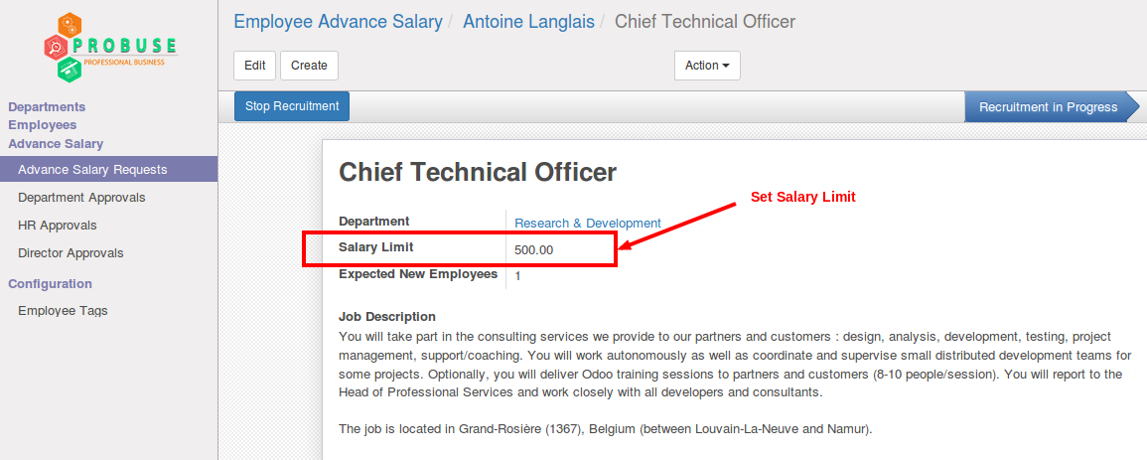

Approved By Department, HR and Director

Menus for top level approvals.

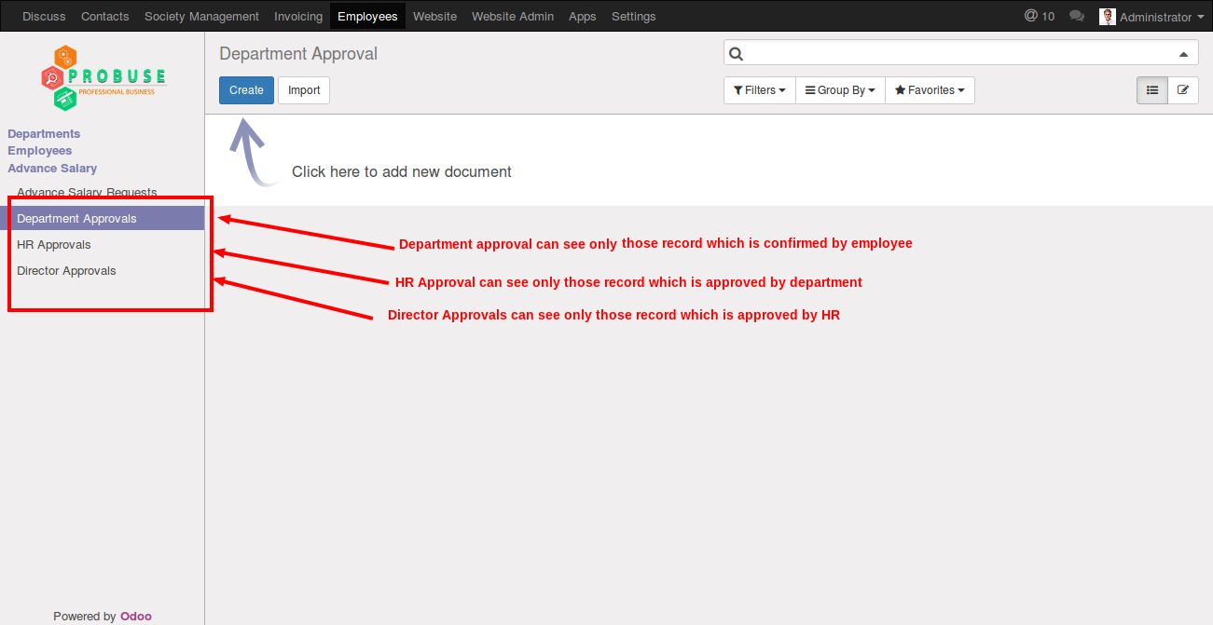

## Advance Salary Request Under Accounting

For accounting department we have given menu which will allow them to see all requests which are approved by director of company.

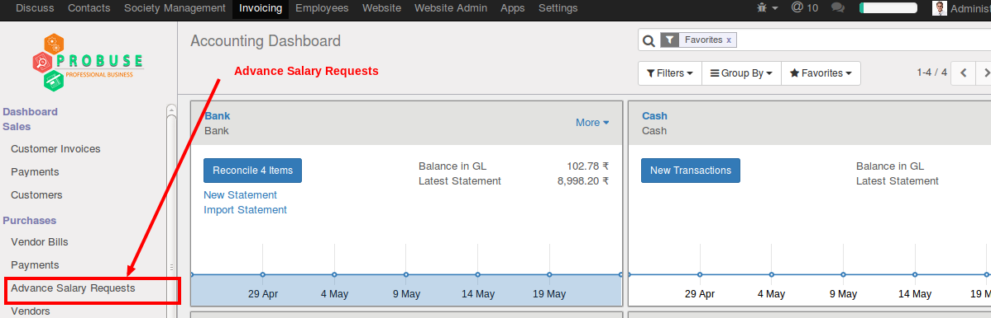

Print Employee Advance Salary Report

Qweb PDF report to print request with all information

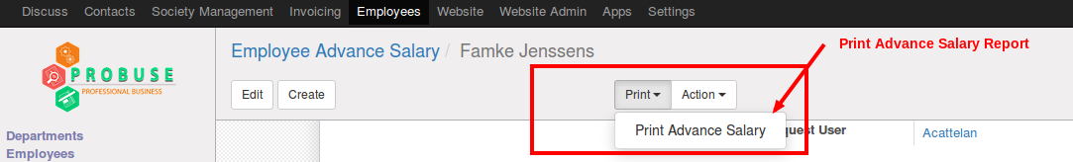

Advance Salary Report

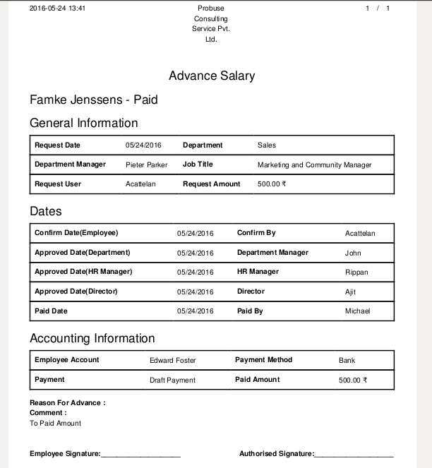

Payment to Employee by Accounting Department

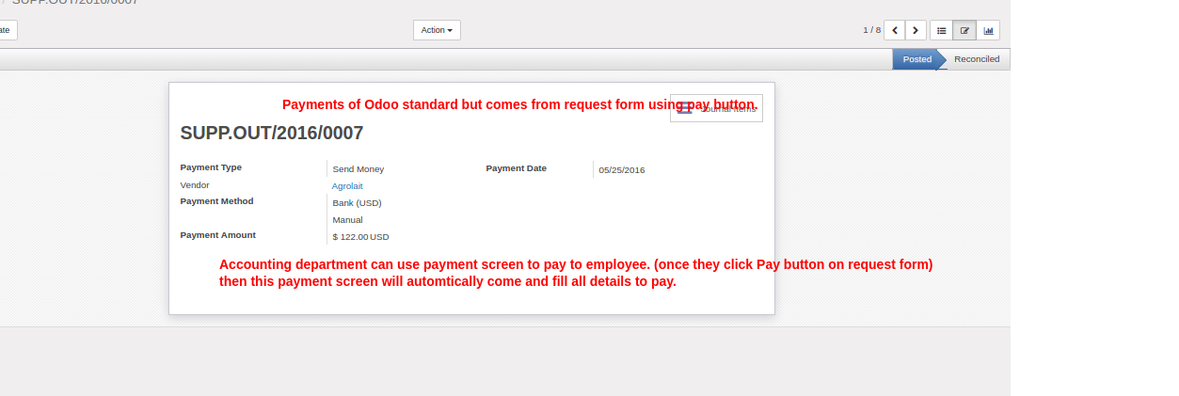

Employee Payslip Showing Deduction

